DEMO/LAB: Springs & Elastics in Parallel vs Series

Overview: This lab will be using rubber bands to model springs k constant when in various configurations

Materials needed:
Meterstick version:
3 pencils
Heavy Textbook
Various rubber bands
Phone Camera with slo mo
Meterstick
Scale to find weight of pencil, or find answer in terms of “pencils”
Twist ties

Note:you need some way to measure vertically, for the displacement of the rubber and and for the vertical height maximum it reaches

Procedure
Finding K for one rubber band:
- Place two pencils parallel to each other, half of the pencil off the ledge of a table, and use a textbook to hold them in place
- Place a rubber band on the pencil and pull it down until you find it's equalibrium position
- From here, pick a vertical displacement down from the equilibrium and note it down
- Put a pencil in the rubber band while it's displaced
- Let go of the rubber band and be sure to find it's vertical maximum when it's launched. You can use a video camera to see exactly what it's vertical height is
- If you do not have a meterstick tall enough to measure the height, you can perform kinematics to directly calculate exit velocity(fig 2) use your video recording to find the time it took to go from launch exit position to the maximum height
- Take several videos to ensure accuracy and then average the result
- Repeat the procedure with several different displacements to ensure accuracy
Finding K for rubber bands in parallel and in series
Refer to the diagrams on how to set up the rubber band in series and in parallel

Single Band (equalibrium) | Paralell (equalibrium) | Series (stretched out)
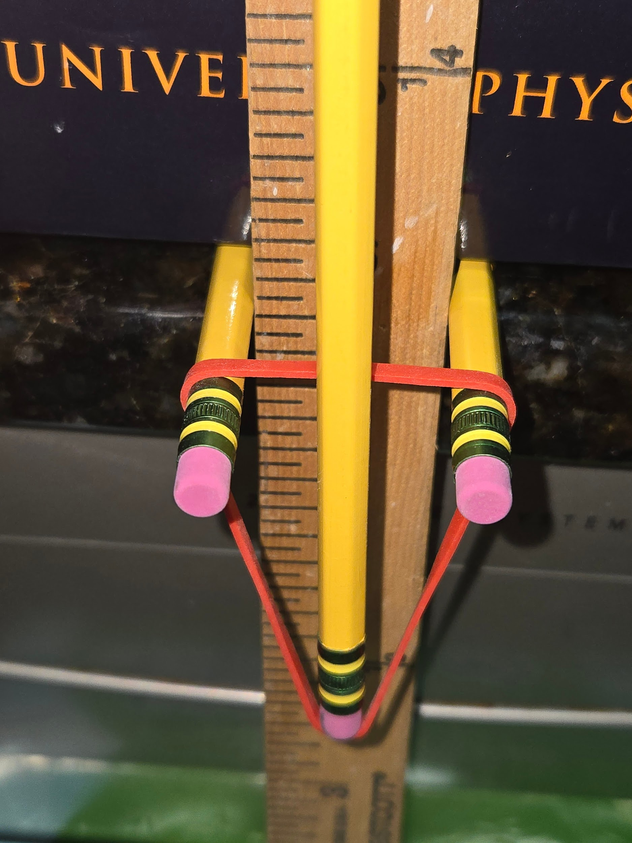 | 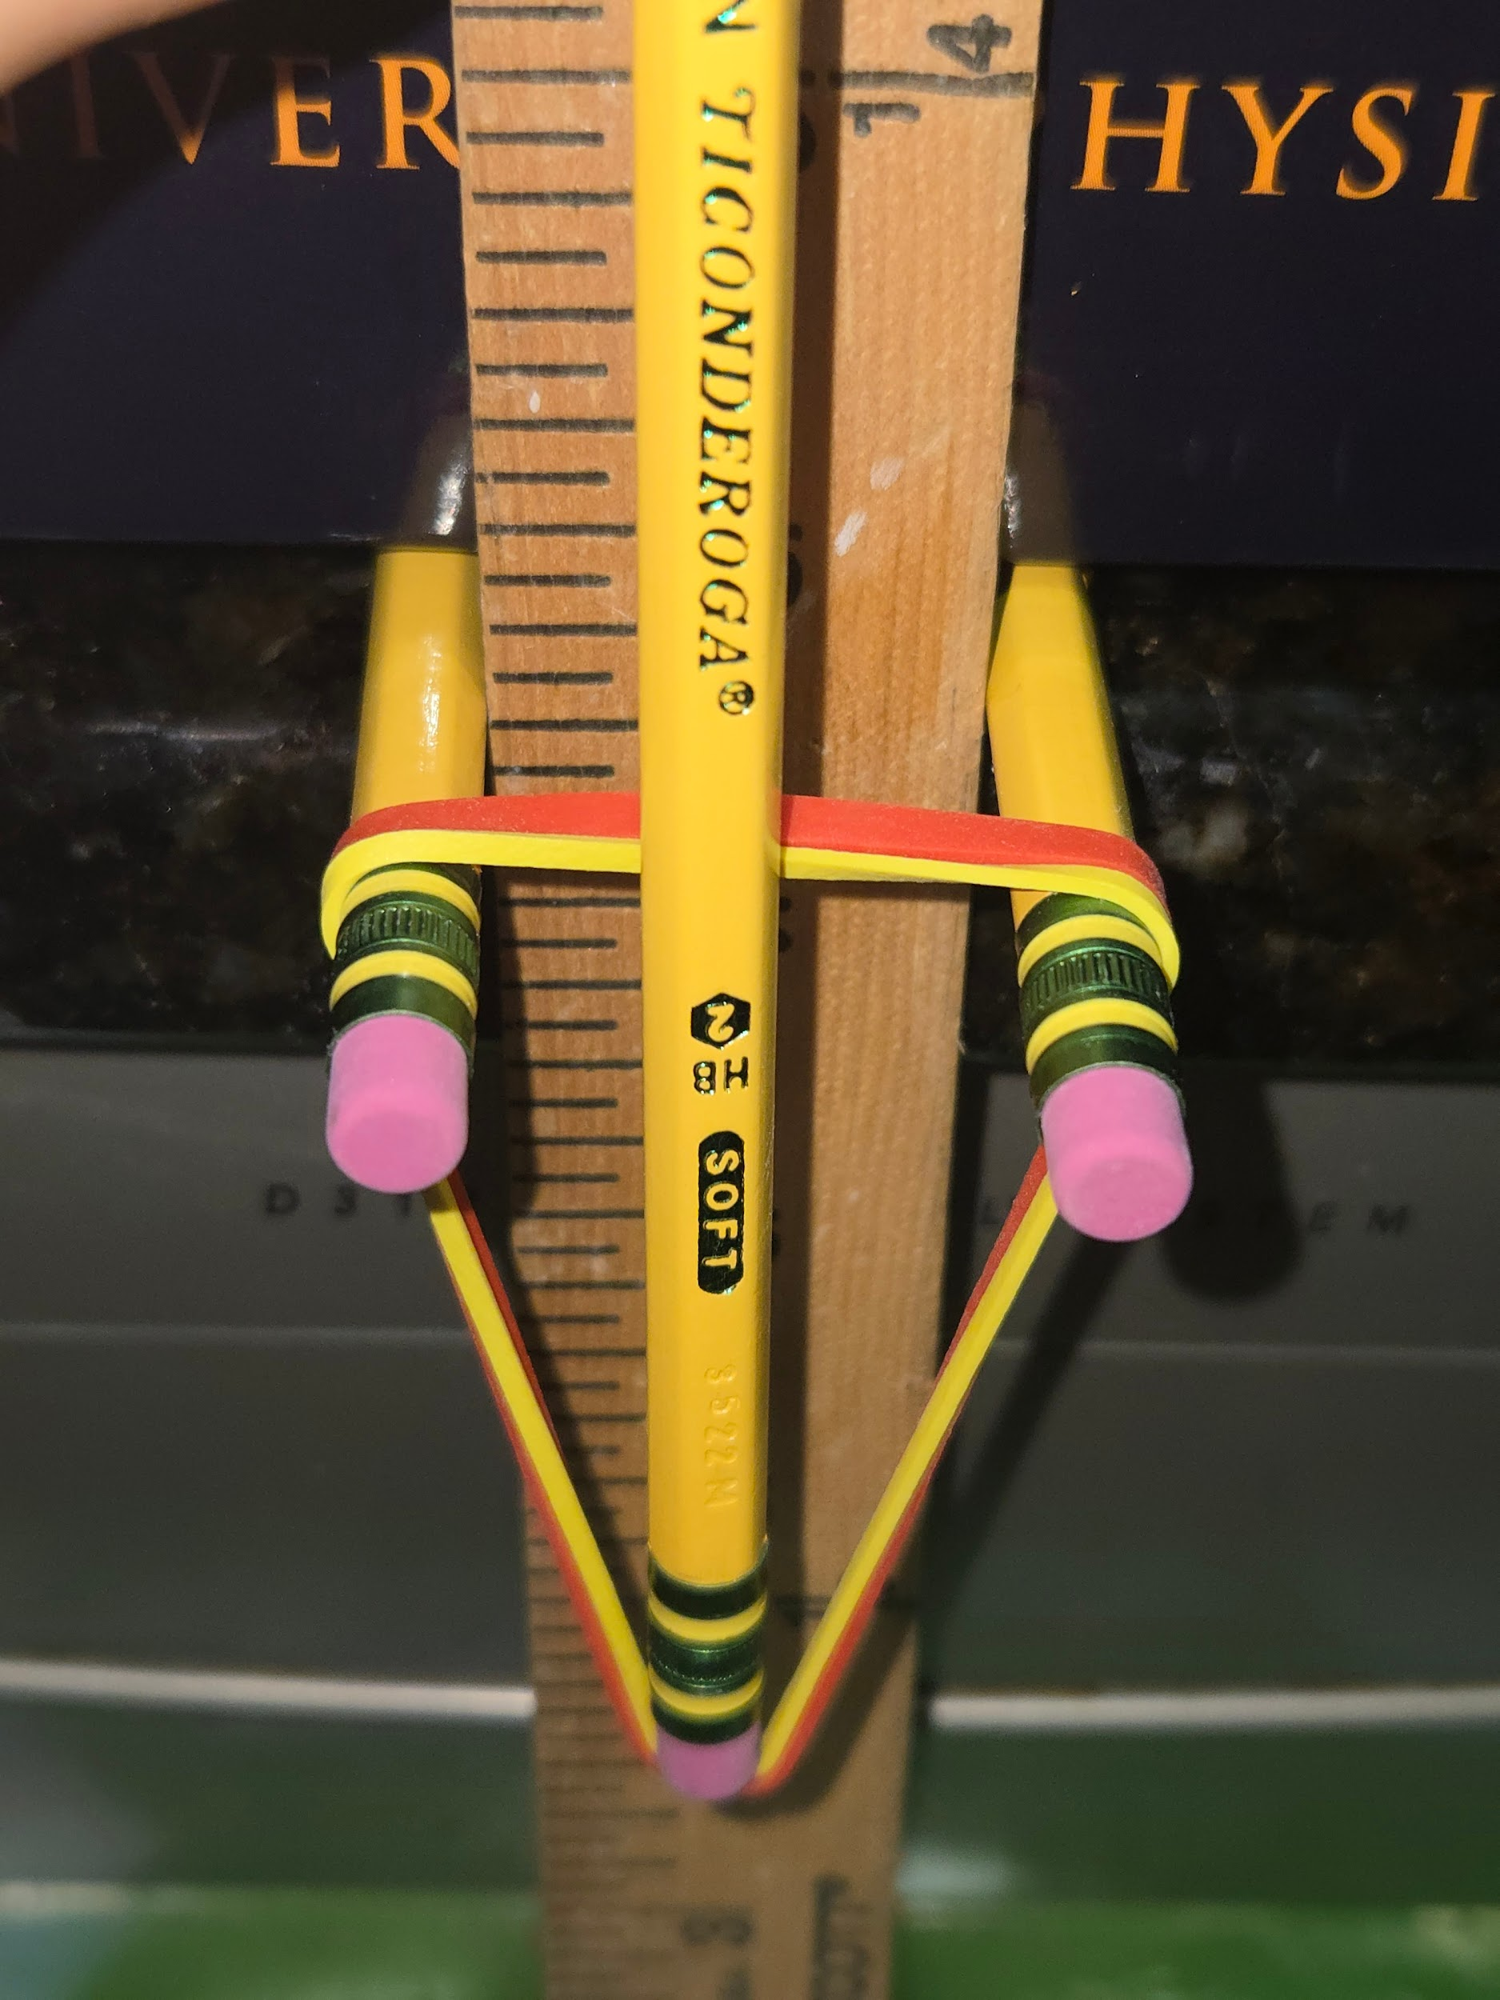 | 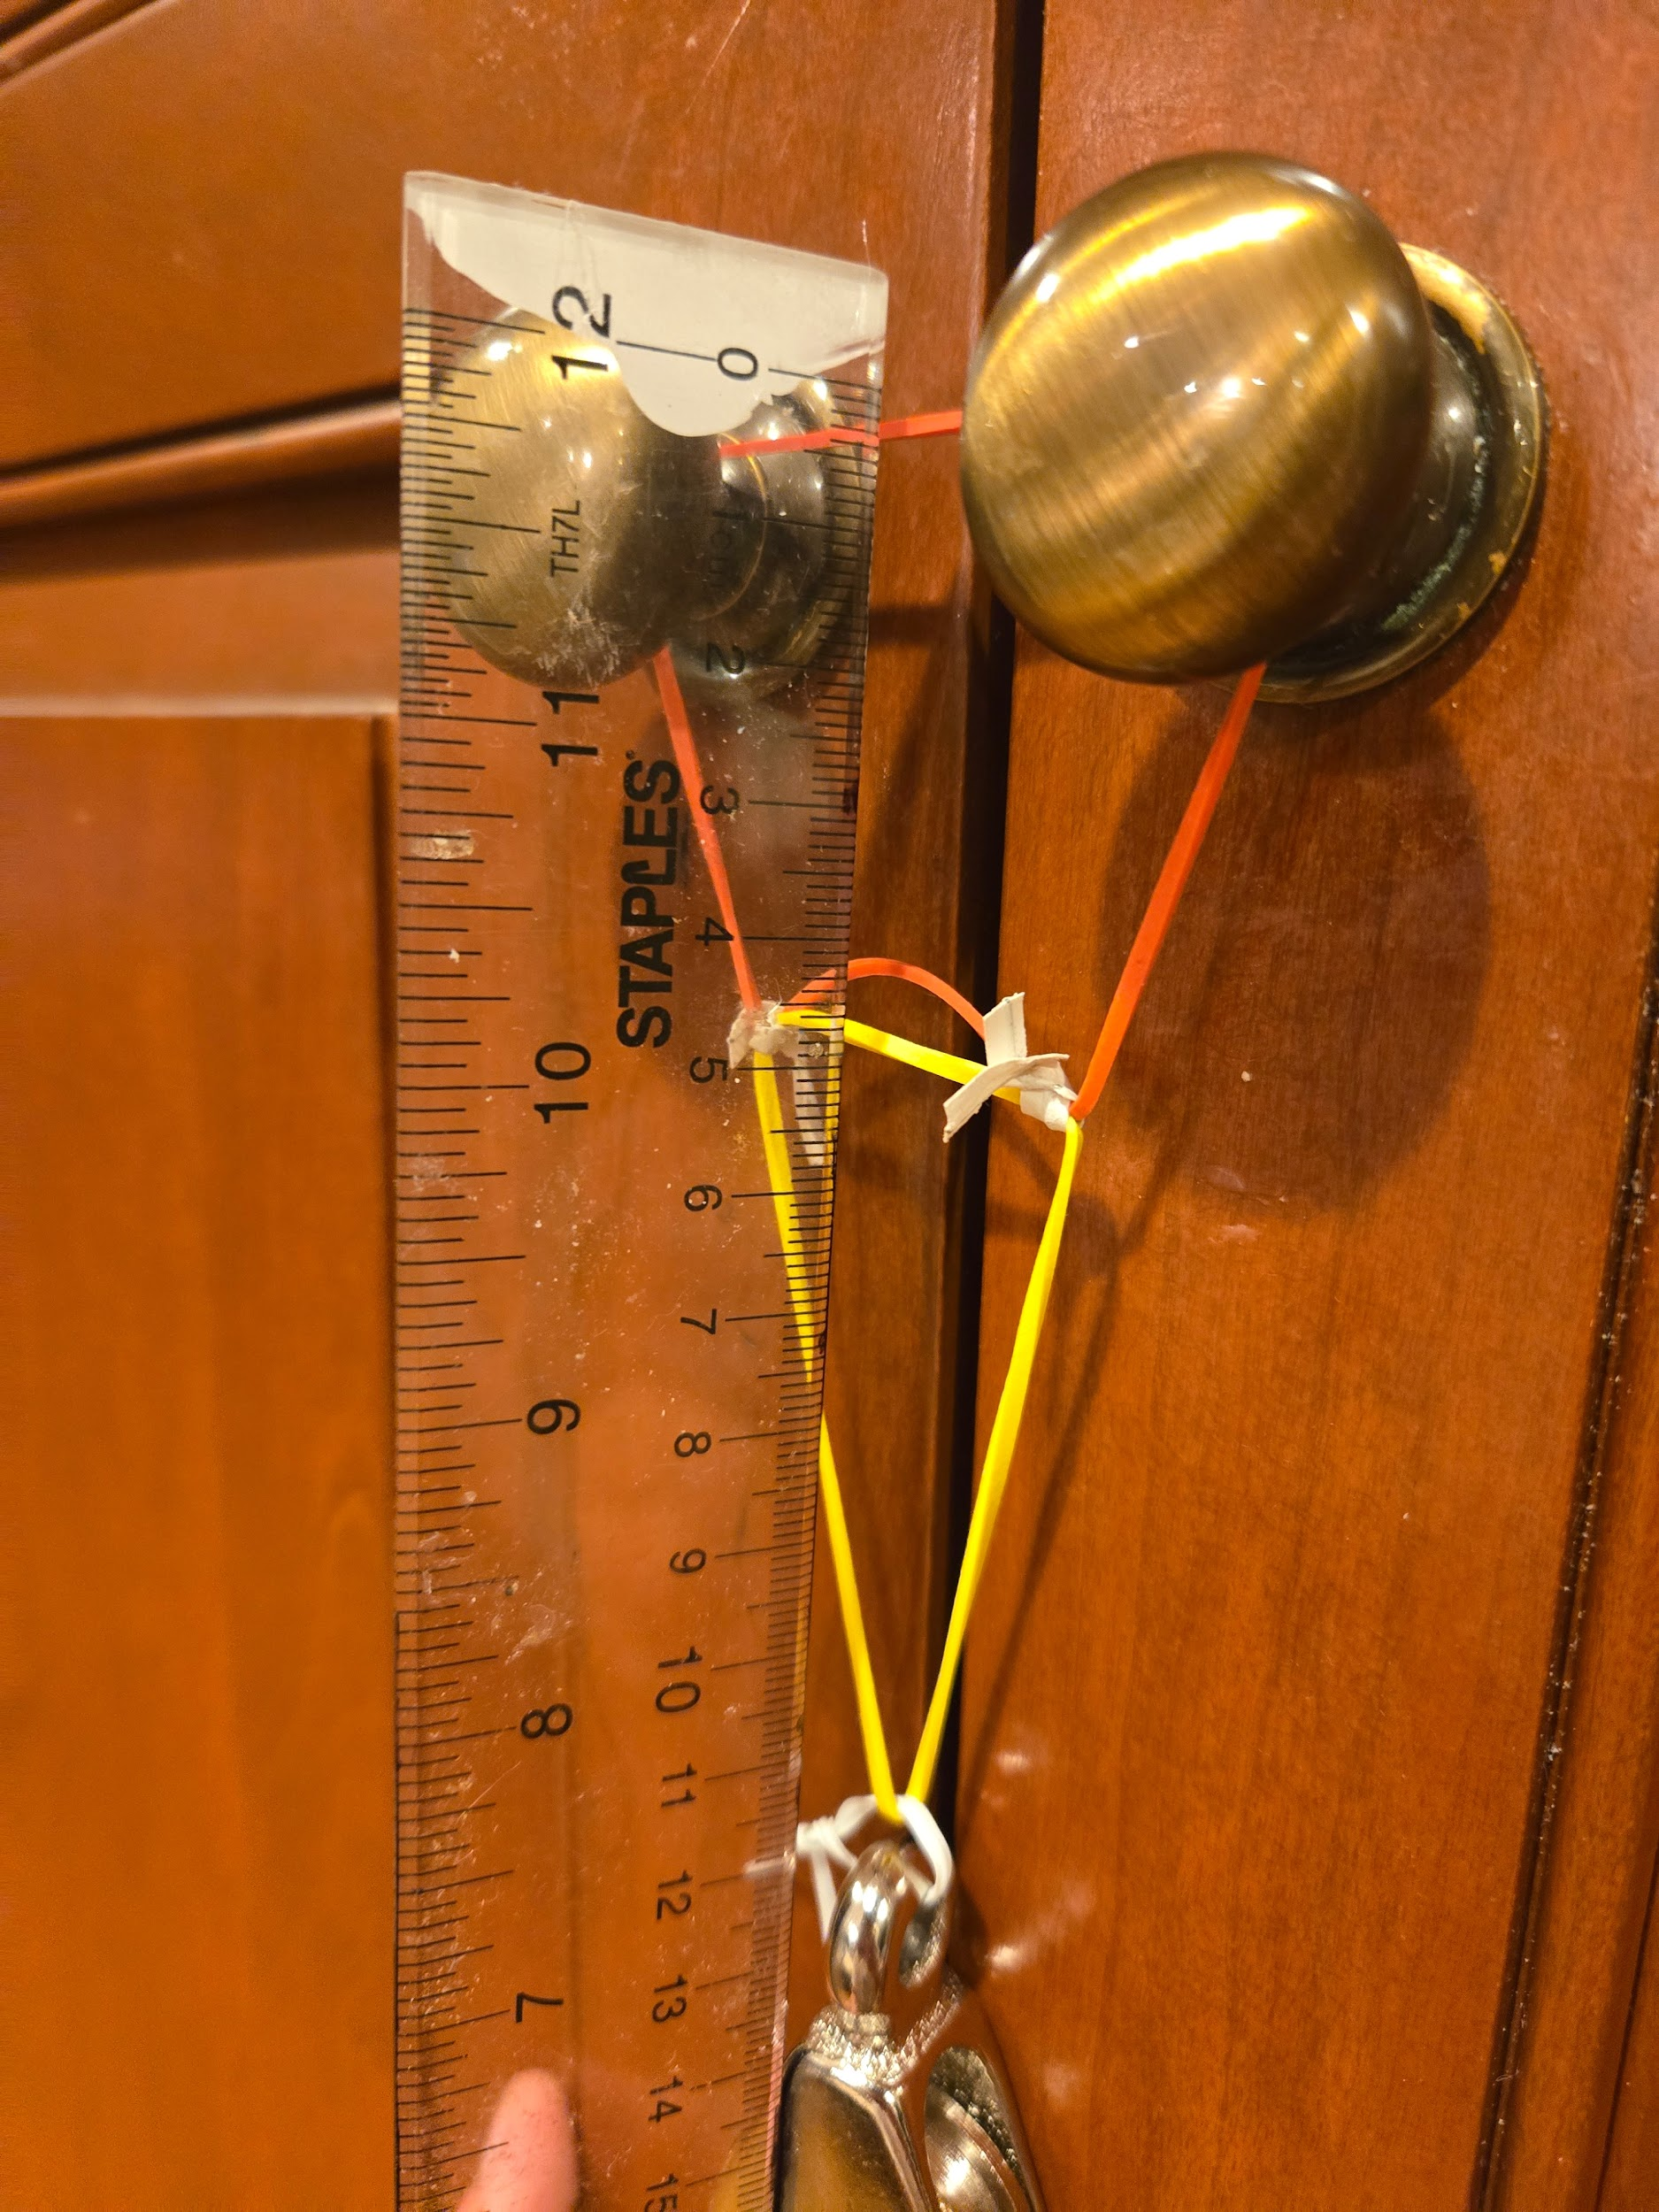

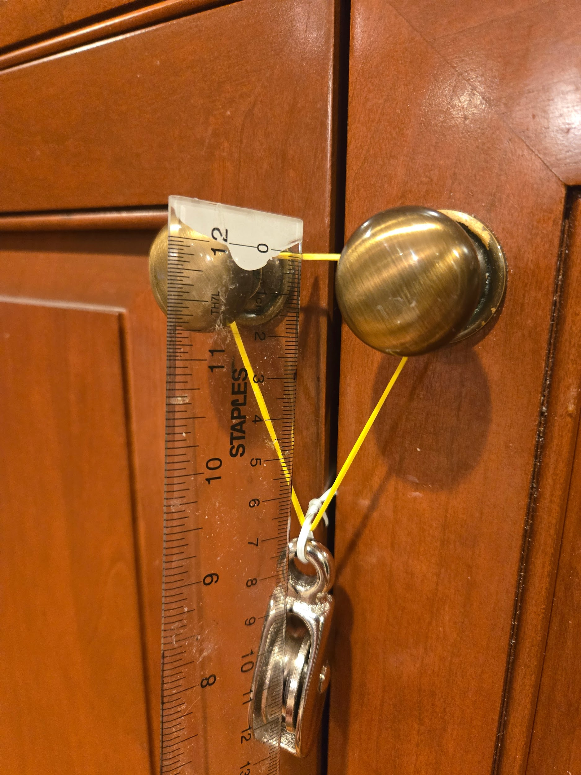
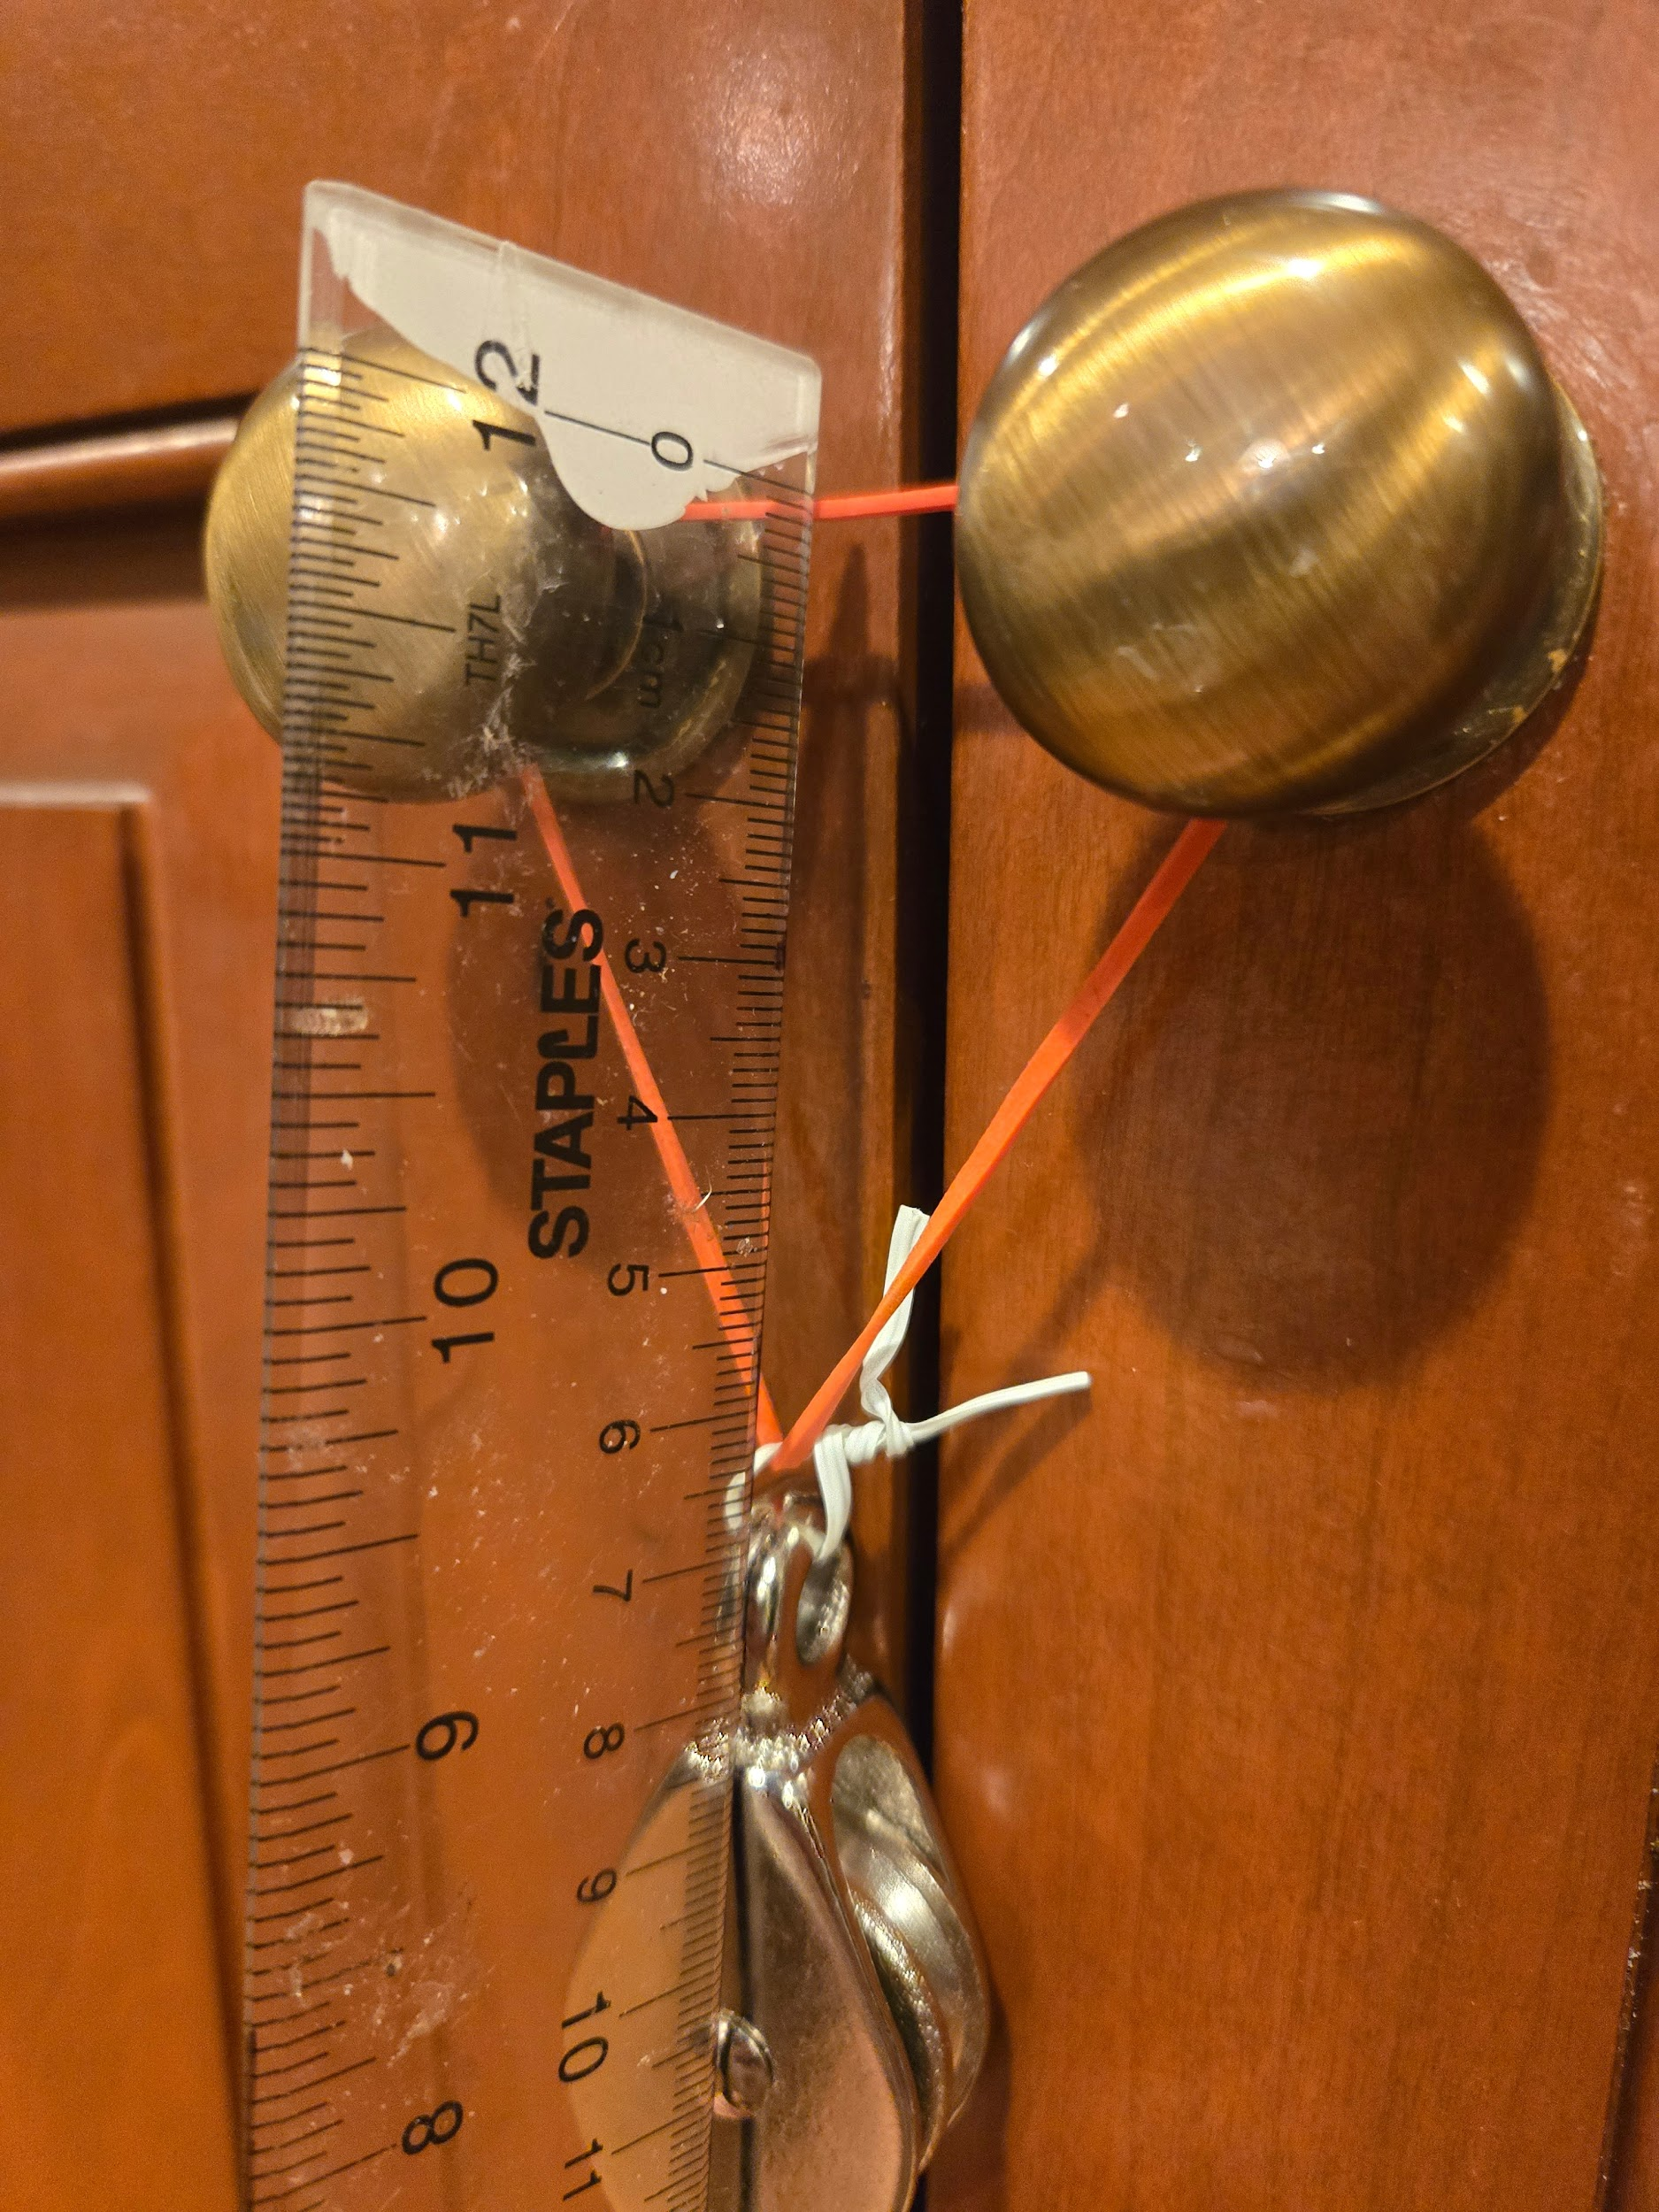
proving that my series configuration works

Test question
If I put use a weight to find the relative displacements between the rubber bands by themselves and then together in series (the way i think it would work for them to be attached), I can find out whether the way I attached them is equivalent to attaching them in series

both ~ 12cm<<13
yellow ~ 7cm
red ~ 6.5cm

$F=kx$
$k=\frac{F}{x}$
$k_{b}=\frac{F}{12.6}$
$k_{y}=\frac{F}{7}$
$k_{r}=\frac{F}{6.5}$
$\frac{1}{k_{b}}=\frac{1}{k_{r}}+\frac{1}{k_{y}}$
$12.6≈7+6.5$
$7+6.5=13.5$
Margin of error <1
Result: my method is adequate to result in series behavior

Lab tables

Rubber band 1
Displacement:_______________
Trial | Height
1
2
3
4
5
average
Feel free to do more trials for accuracy

Rubber band 2
Displacement:_______________
Trial | Height
1
2
3
4
5
average

In Parallel
Displacement:_______________
Trial | Height
1
2
3
4
5
average

In Series
Displacement:_______________
Trial | Height
1
2
3
4
5
average

Calculations
Using the data you collected, determine a formula for finding k. Variables should include h (height), m (mass of pencil), x (displacement of rubber band from equilibrium)

Using your derivation above, calculate the experimental value for K in each of your tables.

In AP Physics C Electricity and Magnetism, it is learned that components in series are added together while components in parallel are sums of each component’s inverse. Student B claims that the behavior of rubber bands should be the same. Using your calculated data, explain whether Student B’s claims are correct or incorrect.

Post Lab Questions
- How does the behavior of rubber bands in parallel differ from those in series when a weight is applied? Describe the difference in terms of displacement and constant K

- Based on your height measurements, which configuration had the highest launch height if they were to be at the same displacement? Does this match your conclusion in response to Student B?

- How does conservation of energy take place in this lab?

- If you were to double the number of rubber bands in paralell, what would happen to the height?

